Cleansed
Purified
Set Free
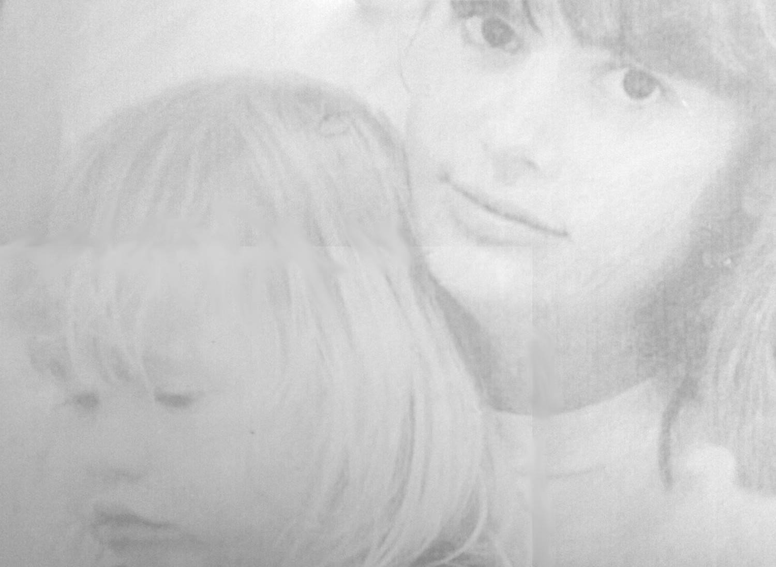
By Kat Kanning

This is the story of my life. It’s very sad in places, ugly in places, and wonderful in places too. I write this now in hopes that what I’ve learned will help others, so maybe others won’t have to suffer the pain that I went through.

I was a happy little kid. I used to sing a lot. I spent hours wandering the fields and woods in Oregon, with my big dog as companion. I loved to watch the birds and creatures. It delighted me. My father was a beekeeper, and I spent hours sitting in front of bee hives watching the empty bees leave, and the bees loaded with pollen coming back into the hives.

It was a pretty normal childhood, I guess. Until something happened that sent my life into a tailspin for many years. My brother raped me when I was 9. After that horrible experience, it was like there was something in me that gave me an obsession about sex.

At 13, I had sex more or less willingly for the first time. After that there were many boyfriends to follow that first experience, up until I was 17. At that time, I was prepared to go off to college at Oregon State. But something happened. I became pregnant. I thought my college plans would be ruined if I had a baby. So without thinking much about it, I had an abortion. My mother had once told me never to tell her if I had an abortion, so I didn’t. I did my absolute best to never think about it, either.

Life went on. I graduated from college and got married. After a few years, we had a baby. It was a beautiful, amazing baby girl. I think back on the day my daughter was born. I was filled with such wonder that from our bodies, this whole new life was formed. I was still an atheist at the time, so I didn’t realize that it was wonder at God’s creation. There she was, a living being, created out of the matter of this world and somehow endued with this ineffable thing, life.

This baby was so beautiful and wonderful, but I was not able to draw near in my heart to her like I should. There was something dark inside me. I got really depressed after she was born. I thought it was postpartum depression, but it didn’t really go away, so now I think it was because of the abortion, which I was steadfast in not thinking about.

Later, I found that my obsession with sex hadn’t gone away. I had an affair. Then I talked my husband into having an open marriage. Things really went downhill from there. I tried to cover over the depression with men. I couldn’t stop. I was seducing men and then leaving them. I broke up at least one marriage (other than my own). I got pregnant two more times, and aborted both babies because I believed I had postpartum depression that was so severe, that I didn’t want to go through that again. Never did I think about how I was killing my own sweet children.

Then another horrendous thing happened, and it was my fault. One of the men I was messing around with molested my daughter. If I hadn’t been messing around, it never would have happened. I walked in on it happening. I was so freaked out, I called the police just to get him to go away. He left, and I hung up on the 911 call. They called back and eventually got me to tell them what had happened.

After a very painful trial for both my daughter and I, that man went to jail. My husband asked during this time why I was making such a big deal about her being molested. That was the breaking point for me, and I took her and left. We stayed for a while with my mother, then moved to New Hampshire with the Free State Project.

Even after all the pain I had caused, I couldn’t stop the running around with men. I took up with someone new in NH. But that didn’t go any where. Then something amazing happened. I was looking online at some Free State Project info, and I saw a post from this guy Russell Kanning. He had a picture of himself with 3 kids, but it said he was divorced. We talked online and on the phone for a month, and then he flew to NH and we got married. Crazy, I know.

The amazing thing was that he was a Christian and I was an atheist. I told him right off not to try and evangelize me. He didn’t. But one day we were talking and I asked him, “You don’t think I’m going to hell do you? I’m a good person.” He answered that he thought I would go to hell, and gave me the good person test. I failed the test miserably, so it told me also that I was going to hell. I chewed on that for a couple of years.

I was doing great at not thinking or talking about the abortions, or so I believed. I hadn’t told Russell. The only one who knew was my ex-husband. Then one day Russell was just talking and mentioned how he thought abortion was murder. Suddenly, trying to hold all those beach balls under the water, I lost control of them, and began to think about what I had done. What if Russell found out about the abortions? Would he leave me? I was shattered, like flat on my face on the floor weeping. I got to such a dark place, and realized that Russell was happy, and I was not, so I thought maybe I should do what he was doing. I said, “God, I don’t want to fight you any longer. Please forgive me.”

Wow. I was changed then. My new age roommate noticed right away that I was different. She could tell I wasn’t depressed any more. But it was about six months before I told anyone I wasn’t a atheist any longer, but was following Jesus.

I spent my time secretly reading the Bible and listening to praise music. I found out what it was that Jesus had done for me. God decreed the punishment for sin is death, meaning hell. But Jesus paid my punishment for me. I earned death through my murders, my adultery and many other things. It was like I was in court and the judge just gave me the death sentence, but this man walks in and says, “Wait Judge, I will die in her place.” So Jesus died the death I deserved. Even while I was wallowing in sin, running around with men, killing my babies, hurting so many people, Jesus still loved me enough to die so that I might have life. I am so grateful for his mercy to me, I want to live for Him.

Eventually, we had to leave NH to deal with some family issues. I realized that I really was changed. I didn’t have the obsession to sleep with every man I met. I read in the Bible that you can’t be a secret Christian, so I eventually told Russell about it while he was driving us down the road one day. He practically screeched to a halt and said Whaaaat?!? when I said that I’d become a Christian. But I still didn’t tell him about the abortions.

Sometime later, I was praying and I asked God what I should do in His service. That night I had a dream. At that time, Casey Anthony was on trial for killing her little girl, Caylee, and it was all over the news. In the dream, I was Casey Anthony being tried for murder. And in the dream I knew I was supposed to tell people how abortion was murder. But before I could tell other people, I had to tell Russell first. I was so scared that he would reject me. When I told him, he was so kind about it. He didn’t get down on me at all. He set me up at a pregnancy center where they give classes for women who have had abortions. The class taught how women can repent and follow God, and receive his forgiveness and healing. There was a lot more to it, also. It helped a lot.

The Bible says that we are made captive by our sins. This was so true in my case. I couldn’t stop running around with men, even after it hurt my precious little girl so horribly. Jesus came to set the captives free, though, and I was finally set free! But looking back, the wonder at this brand new life is juxtaposed with the regret that I killed my other three children. I may have been forgiven about this, but the sadness and regret will remain. I hurt these innocent little people, and nothing I can do can change that.

Since then, I’ve been open about telling people about my past. I’ve posted my story online. One reaction that surprised me (but shouldn’t have) was from a man. He was grieved that his girlfriend when he was young aborted his baby and gave him no say in the matter. He was so sad about the death of his child.

When Russell and I are street preaching, I tell people my story. Most seem sympathetic. Only one I can think of was mean about it. God instructed me to talk to people about abortion, so now I’m telling you.

If you are ever faced with the incredibly difficult decision to abort your baby or not, I ask you to remember my story. I wish I had made different choices. I wish I would have either let the babies be adopted, or raised them myself, because despite all this, I really love children! I love making them laugh, seeing them learn and grow. I have such delight in my baby grand-daughter now. What joy just from the giggles of a baby!

